**Starting the Program**

To get started, unzip the zip file and launch CurrencyCalculator.py, you may also want to read the README.txt file for important information that may cause your program to not function.

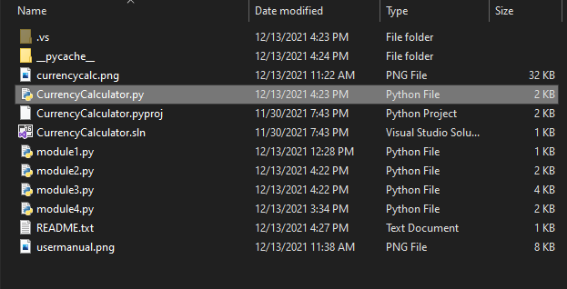

**Main Screen Navigation**

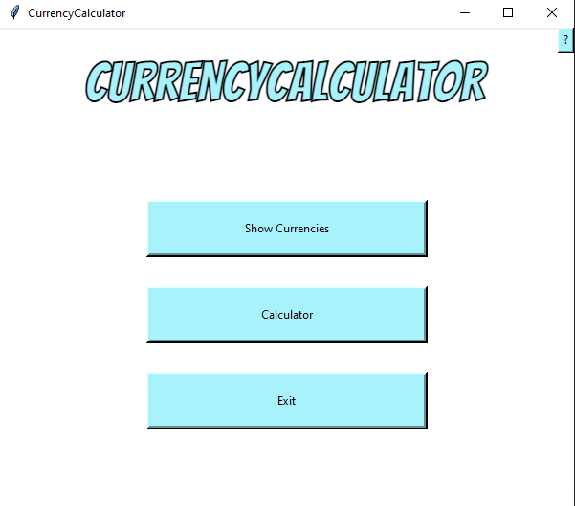

Show Currencies: Will open a new window and display all supported currencies.

Calculator: Will take you to the calculator screen where you can convert currencies.

Exit: Quits the program.

?: Opens the info menu and links to the user manual.

(Note: Every page has a back button to take you to the previous page)

**How to Use the Calculator**

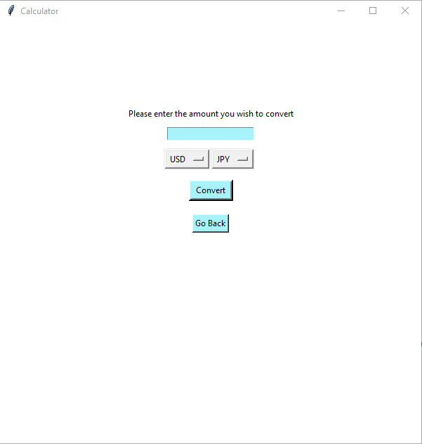

Step 1: Enter the amount you wish to convert in the blue input box.

Step 2: Click the left drop down box to select the currency you have.

Step 3: Click the right drop down box to select the currency you wish to convert to

Step 4: Click the Convert button and your results will be displayed where it says “Please enter the amount you wish to convert”

Step 5: Repeat these steps if you wish to convert something else.

(Note: Only enter whole numbers and no other characters. If you don't, an error will display telling you to only enter integers. You also might get an error message if you enter too big of a number.)